Stranger Things

Etude ONE

By Michael Watts

# 25787955

CART 360

September 20, 2019

michael.mega.watts@gmail.com

­­­­

Stranger Things – Final Chosen object

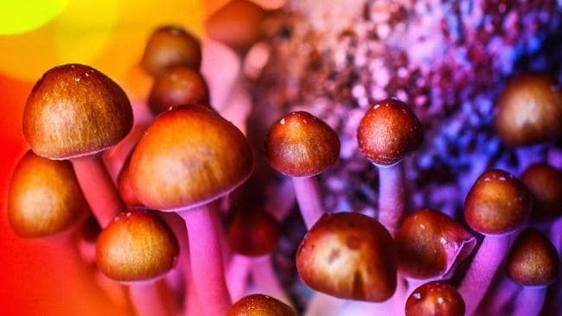**Mushrooms**, or fungi, have played a big part in my creative experience. I am fascinated with their presence in all forms of decomposition and how they represent some type of gatekeeper that guides all living forms through the cycles of life and death and back to life. Many different types are also edible and make for delicious sustenance for us, as well as types like Reishi (mushroom of the soul) that have been known to contain calming and healing properties. One would think that mushrooms are just some random growth, but they are actually very complex. They produce their own internal network system (mycelium) that run like communication filaments and we could describe it as mirroring out cherished internet. Mushrooms come in all kinds of different forms. In general they are kind of spongy will stems and a large cap head. I really like the lines underneath the cap, which remind me of gills from a fish. Others grow in the form of scales and in patches, some very thick like wooden bark and others thin and fragile. There are even bioluminescent fungi that glow in the dark and this is perhaps where I would like my project to go partly.

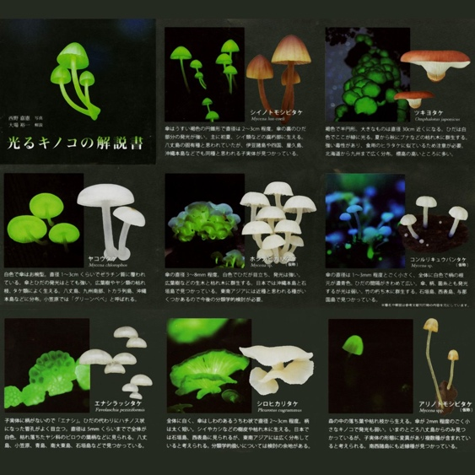

I will highlight psilocybin in particular because of the psychedelic experiences I have had, their positive effects on the brain, depression, creativity and making one more open to the world. My experiences have altered my creativity and created and type of signature for myself that I use in my work. Much of it is about the endlessness of all forms of life and the power and potential of our minds to manifest the world around us. What stays with me the most are the colours, patterns, energy, and layers at which the sensuality of the experiences takes over in the body. And how the body’s limit somehow dissipates when the mind no longer thinks in material form. Everything is fluid and much more representative of how energy is.

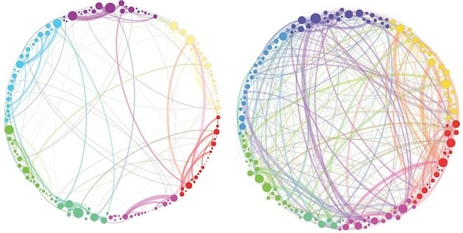

I imagine designing a field of artificial mushrooms, or a large patch under some kind of tree, that light up and gives off heat and various coloured glows when it senses body heat, and perhaps they also release sounds that would create harmony with the other mushrooms. The experience is meant to be calming and therapeutic, something like a happy place one can go to. It can be in a room at a gallery or an outdoor installation set up in parts of the city that are vacant. Maybe these mushrooms glow in sequences and patterns that mimic psychedelic visuals? Or when you talk, they respond.

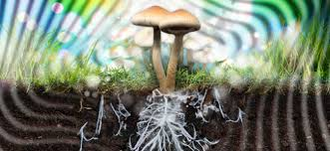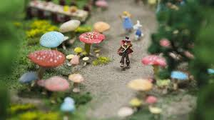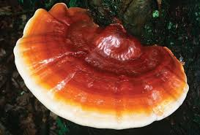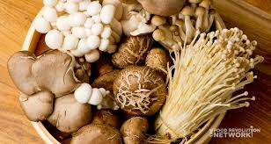

**Space 1** – Large pod (or inside a mushroom) containing artificial field with reactive shrooms and 360 ceiling projecting images.

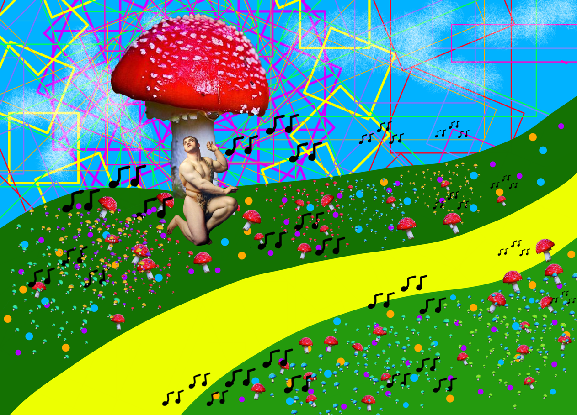

**Space 2** – Room, walls filled with reactive shrooms, ceiling is also reactive on user activity

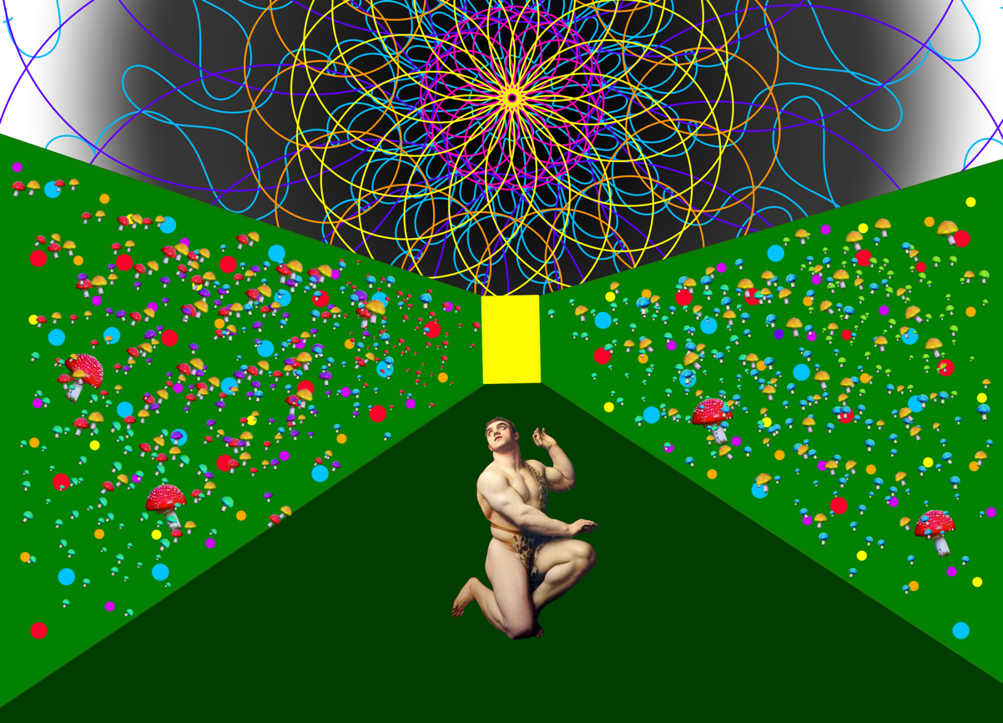

**Space 3** – Underneath viaducts in the city. Installation set up for people to enjoy the space.

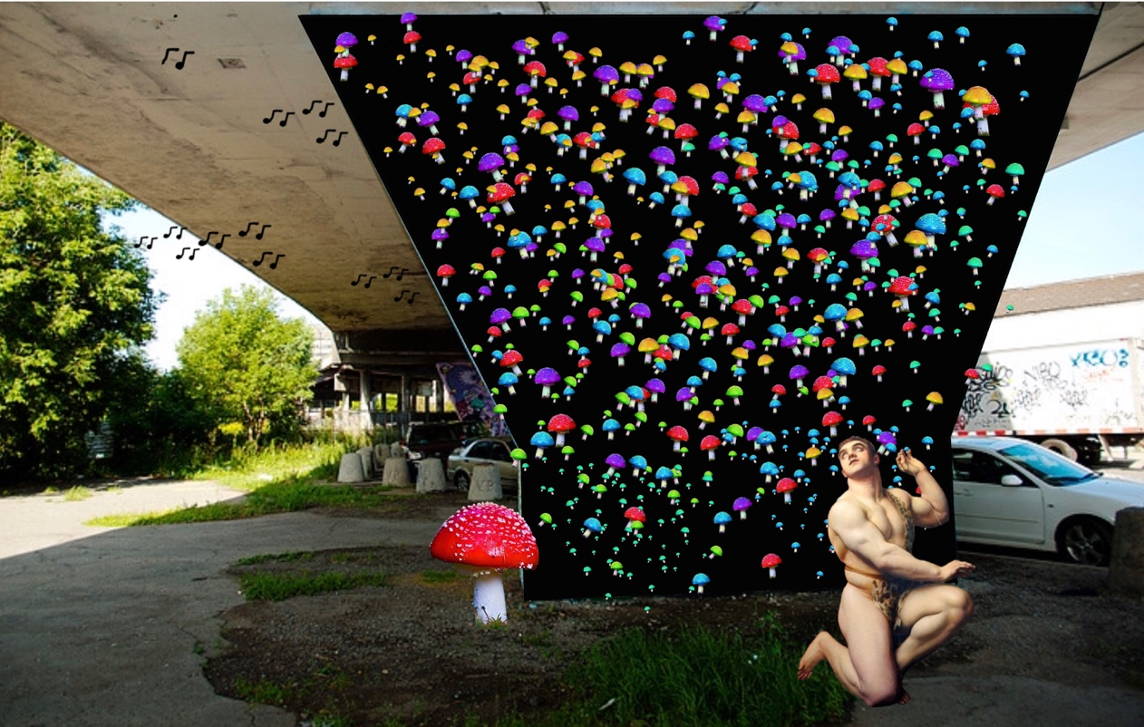

**Back image from** [**viaduc**](https://hiveminer.com/Tags/rosemont%2Cviaduc) **by Antonio Iacovelli**

**Storyboard – Mushroom Pod**

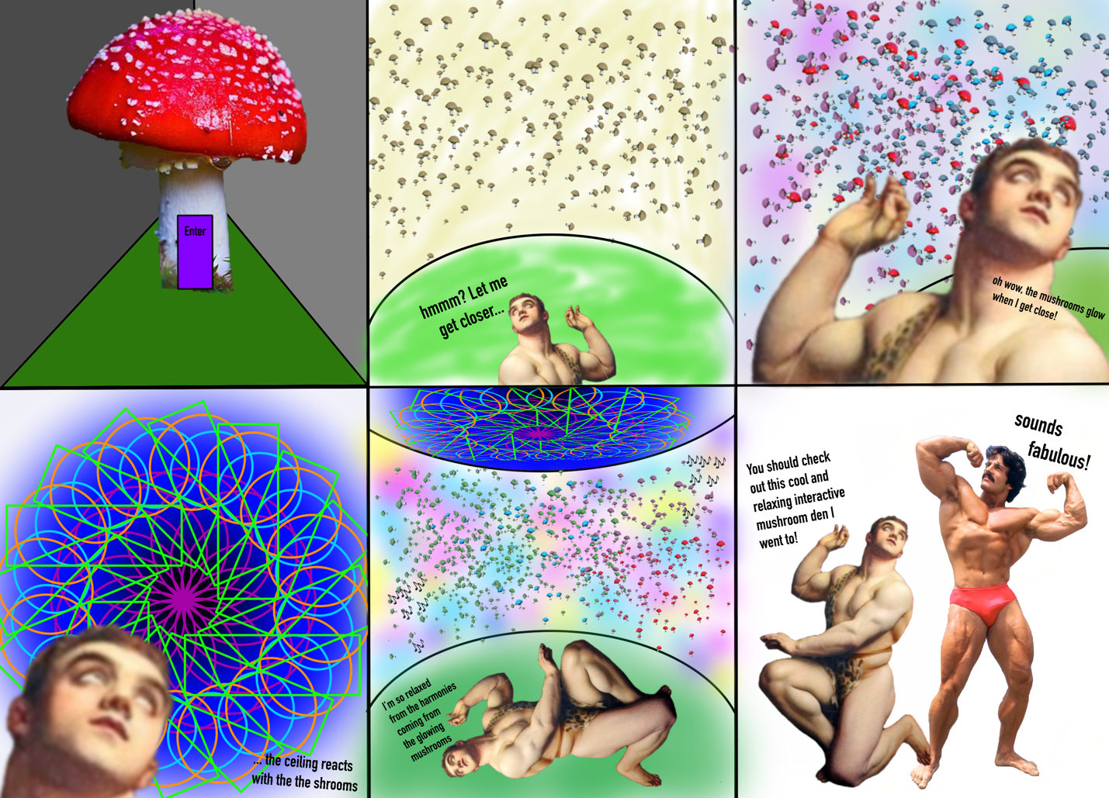

**Other two objects**

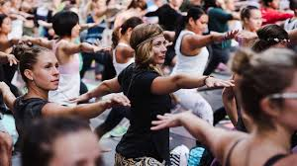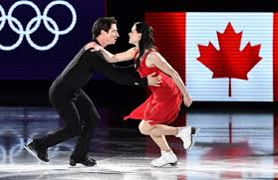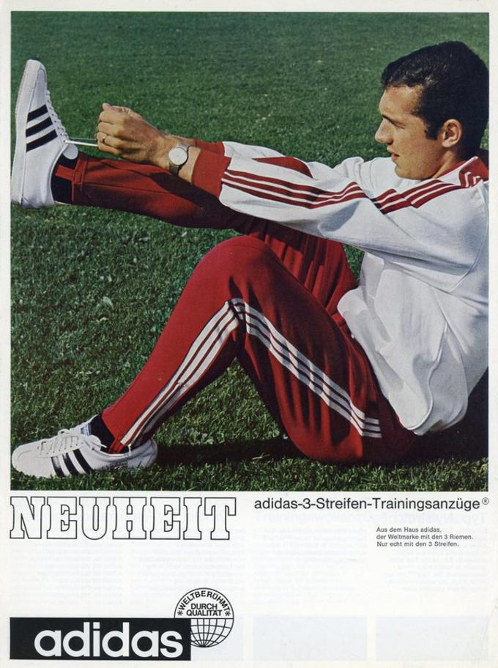**Active bodywear** – I am a very active person and have always been since I was a child. Soccer gear was a big part of growing up during my competitive playing and I even learned to screen print numbers and names on jerseys. Then I became a raving club kid where dancing in flashy outfits with glow sticks to electronic techno house beats became a weekend ritual. If I wasn’t costumed I’d be wearing comfortable track gear so I could let go freely until morning hours. After which I then became a professional dancer, which over the years, had be fit into things like dance belts (basically a thong/jock strap), spandexy jazz dance attire, loose capoeira pants and anything that was resistant to the friction against the floor. All these experiences had me invest in a variety of active wear required to allow my body to move, stay warm or cool, and fit into a certain demographic of people in a close community. Fabric qualities throughout all these phases of my life have transformed and revolutionized, especially within active wear technology and for the various needs of different body types and movement related activities. You can see how important good gear is for people that value the importance of a physically active life. The gear is in no way restrictive (except for compression shorts). All people pretty much benefit from active wear, even if you are not someone who is active. It’s just one of those necessities of living and also a way we express ourselves. My preference now when I go to the gym and lift weights is a mix of polyester and spandex that allow for better movement, breathability, that is not too tight but allows me to still see the progress I am making. What is also important is having access to listening to music and following workout videos on my iPhone. If I can’t do this comfortably and without fussing I will change gear. One thing to consider is active wear that is ecologically friendly and sustainable. I’ve recently discovered Icebreaker clothing that is made with merino wool. This is a longer lasting fabric and therefore more ecological, plus body odour doesn’t develop.

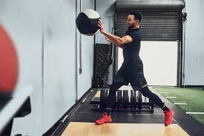

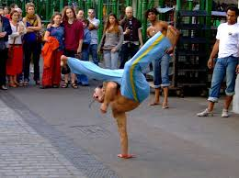

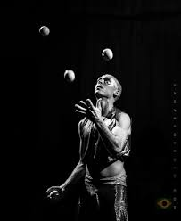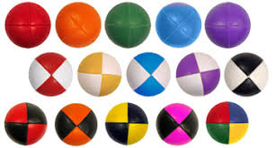**Juggling balls (and other objects) –** As someone that works in the circus world I have always found juggling to be a fascinating activity. My first encounter with juggling was as a child when my father thought to learn juggling for himself, which did not last. So I decided to pick up the abandoned juggling balls and figure it out. I learned to juggle 3 at the basic level but quickly lost interest as well. 20 years later when I started working at the National Circus School I was surrounded by students who either knew how to juggle or were learning as part of their curriculum. I picked them up and magically I could still juggle three the way I did as a child. It blew my mind how my mind/body coordination remembered how to do this. Imagine the benefits this could have for rehabilitation of all kinds was what I thought. Reading up a bit more about juggling I learned that it’s an excellent activity for building coordination, memory, for waking up the brain and engaging in a personal activity that requires practice and persistence. There are also rhythms that you have to follow and certain mathematical sequences depending on the number of balls you use. Juggling is not only limited to balls, but also pins, hoops, umbrellas, apples, blocks, and the list goes on. There is a lot of research and development in what kind of materials can be used and how these objects can be manipulated for pleasure or show. These various juggling objects all have certain properties that react differently to the body, the floor, the air and can offer a multitude of playful ways to create a relationship with the object. Juggling materials and practice can easily resonate with anyone wanting to develop their coordination in a playful way while perhaps discovering a passion for the circus. This is a world of possibilities where the body, mind, and creativity are endlessly challenged. Although juggling is often a solitary experience, it can also be played in groups and games can be developed for competition, fun, social and communication needs, as well as demonstrate how important relationships and partnering are. Various materials could potentially be married with other materials to conduct electricity, allowing for interactive elements to become a part of the jeu, lights, sounds and special effects.

